Activity Guides & Program Models

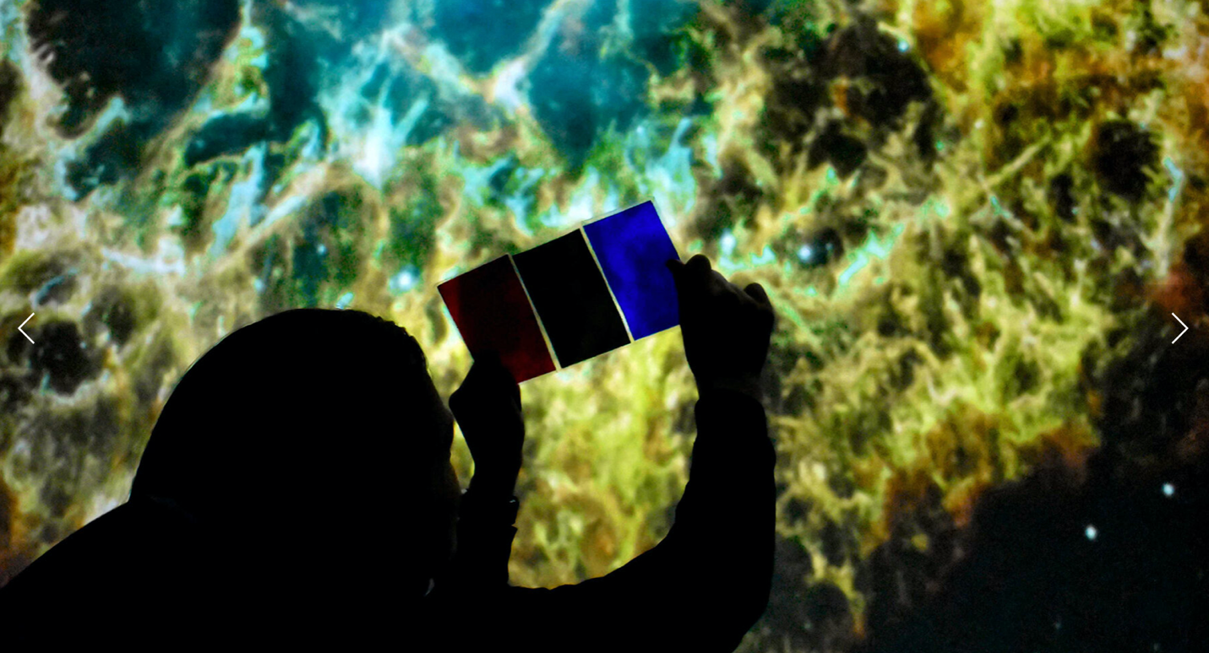
- The Expanded Universe: Playing with Time , in this activity, participants use balloons to model the expansion of the universe and observe how expansion affects wavelengths of light and distance between galaxies.
- Laguía de actividades del universe expandido
- Trappist-1 System Scale Model , these materials may be used to create a scale model of the TRAPPIST-1 system in a small space. This model can be used as a pop-up exhibit to share the breaking news with a wide audience at museums, libraries, and other informal education spaces.
- Modelo a escala del Sistema TRAPPIST-1
- Light and Color: Exploring Visible Light
- NASA’s Universe of Learning Girls STEAM Ahead Program Cookbook Recipe 1: The Electromagnetic Spectrum This Program Cookbook is a guidebook for facilitators planning their own event using NASA’s Universe of Learning resources.
- NASA’s Universe of Learning Informal Learning Network Program Models Informal learning institutions have developed and tested sustainable models of innovative STEM learning for their audiences. These models utilize NASA Astrophysics assets and resources in making STEM learning more accessible and compelling.
- Mad Science: Seeing Starlight with the James Webb Space Telescope In this activity for ages 8-12, learners make bracelets representing different parts of a star’s lifecycle and learn how Webb will study the beginnings of a star’s life.
- Related NISE Network Activities
  - Exploring the Universe: Nebula Spin Art (included in the Explore Science: Earth & Space 2020 toolkit)
  - Exploring the Universe: Star Formation (included in the Explore Science: Earth & Space 2020 toolkit)
  - Exploring the Universe: Space Guess Quest Game (included in the Explore Science: Earth & Space 2019 and 2020 toolkit)
  - Exploring the Universe: Expanding Universe (included in the Explore Science: Earth & Space 2019 toolkit)
  - Exploring the Universe: Pack a Space Telescope (included in the Explore Science: Earth & Space 2018 toolkit)
  - Exploring the Universe: Filtered Light (included in the Explore Science: Earth & Space 2017 and 2019 toolkit)
  - Exploring the Universe: Exoplanet Transits (included in the Explore Science: Earth & Space 2018 toolkit)
  - Exploring the Universe: Imagining Life (included in the Explore Science: Earth & Space 2017 toolkit)

