General Resources and Links

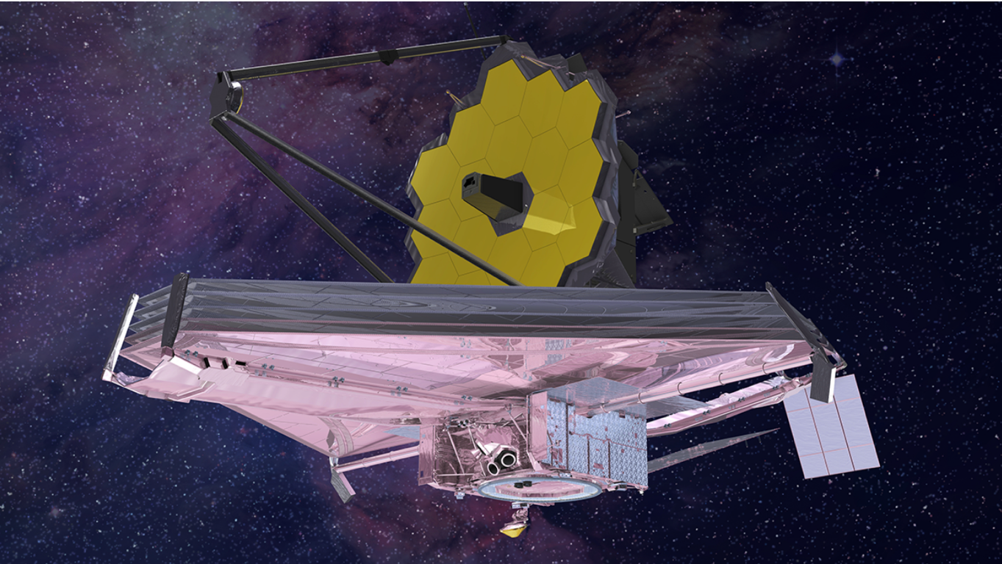

21 Ways to Celebrate the Launch in 2021 from NASA
Webb promises a multitude of discoveries related to our understanding of the universe. As the countdown toward launch in French Guiana, South America, in Fall 2021 begins, here is a wide-ranging list of 21 ways to learn about and celebrate Webb.
James Webb Space Telescope Website for Public Engagement Materials
We wonder. It’s our nature. How did we get here? Are we alone in the universe? How does the universe work?
The James Webb Space Telescope is NASA’s ambitious scientific endeavor to answer these questions, in partnership with the European and Canadian space agencies. Webb will build on the legacy of previous space-based telescopes to push the boundaries of human knowledge even further, to the formation of the first galaxies and the horizons of other worlds. Explore the universe with Webb.
Recursos en Español
A continuación, se presentan los recursos en español sobre el telescopio espacial James Webb de la NASA y la ciencia detrás de este. Es posible imprimir, descargar y compartir todos los recursos de forma gratuita. Se agregarán recursos adicionales a medida que se produzcan.
Follow Webb using #NASAWebb on NASA's social channels, Twitter and Facebook.
NASA’s Universe of Learning Science Briefings
NASA's Universe of Learning Science Briefings are professional learning experiences for the informal science education community, done in partnership with the NASA Museum Alliance and NASA Solar System Ambassadors. These thematic briefings highlight current NASA astrophysics explorations and discoveries from across the suite of NASA astrophysics missions.

Additional Astrophysics and Space Telescope Resources
- Webb Mission Page for the latest news and updates!
- The James Webb Space Telescope Project Page for more news, media resources, and up to date science content!
- NASA’s Universe of Learning provides resources and experiences that enable youth, families, and lifelong learners to explore fundamental questions in science, experience how science is done, and discover the universe for themselves. Using its direct connection to the science and the experts behind the science, NASA’s Universe of Learning creates and delivers timely and authentic resources and experiences for youth, families, and lifelong learners. The goal is to strengthen science learning and literacy, and to enable inquisitive learners to discover the universe for themselves in innovative, interactive ways that meet today’s 21st century needs.
- Hubble Space Telescope Image Gallery for exploring the newest image releases!
- Find Subject Matter Experts for your James Webb Space Telescope event!
NASA’s Universe of Learning works to ensure that Subject Matter Experts (SMEs) are paired with educators and learners in a way that makes sense. If you are working on a product or an event and have an opportunity that could be enhanced with a SME, please follow the link Request a SME for a Learning Activity

